TECHNICAL REPORT ON STUDENT INDUSTRIAL WORK EXPERIENCE SCHEME (SIWES)

AT

METRO GRID NIGERIA LIMITED,
JABI, ABUJA

FROM: 6TH OCTOBER, 2024
TO: 29TH JANUARY, 2025

TITLE PAGE

BY

MOHAMMAD HASSAN
(SE/ARC/ND/23/015)

SUBMITTED TO THE DEPARTMENT OF ARCHITECTURAL TECHNOLOGY, FEDERAL POLYTECHNIC MUBI, IN PARTIAL FULFILLMENT OF THE REQUIREMENT FOR THE AWARD OF NATIONAL DIPLOMA (ND) IN ARCHITECTURAL TECHNOLOGY

APRIL, 2025

DECLARATION
This is to declare that I, MOHAMMAD HASSAN with registration number SE/ARC/ND/23/015 undertook my four months SIWES at METRO GRID NIGERIA LIMITED, JABI, ABUJA and have acquired all the experience compiled in this report in the course of my SIWES.

……………………………….. ……………………………
MOHAMMAD HASSAN Sign/Date

CERTIFICATION
This is to certify that this report compiled by MOHAMMAD HASSAN (SE/ARC/ND/23/015) meets the requirements of governing the award of National Diploma (ND) of the Federal Polytechnic Mubi, and is approved by:

………………………………. …………………………
Name of Supervisor Date
Departmental Supervisor

………………………………. …………………………
Arc. Daniel Barka Date
Departmental SIWES Coordinator

…………………………………. …………………………
Arc. Usman Mohammed Date
Head of Department

DEDICATION
I dedicate this technical report to my parents, my sisters and colleagues and to all those that supported me throughout my industrial training.

ACKNOWLEDGEMENTS
First of all, my sincere appreciation goes to Almighty God and salutation to my prophet.
I wish to thank all staff of Architectural Technology department in Federal Polytechnic, Mubi.
My appreciation goes to my beloved parent for the motivation, prayers and financial support towards my SIWES exercise.
My special thanks go to my beloved brothers and sisters for all their care and support throughout my industrial training.
I want to also thank my colleagues and others; I really appreciate your efforts.

TABLE OF CONTENTS
TITLE PAGE i
DECLARATION ii
CERTIFICATION iii
DEDICATION iv
ACKNOWLEDGEMENTS v
TABLE OF CONTENTS vi
ABSTRACT viii
CHAPTER ONE 1
1.0 INTRODUCTION 1
1.1 Aim of SIWES 1
1.2 Objectives of SIWES 1
1.3 Brief history of SIWES and ITF in Nigeria 1
1.3 Significance of SIWES to students 2
CHAPTER TWO 3
2.1 BRIEF HISTORY OF METRO GRID 3
2.2 ORGANIZATIONAL CHART 3
CHAPTER THREE 4
3.0 DESCRIPTION OF WORK EXPERIENCE 4
3.1 DEMOLITION OF BUILDING USING EXCAVATOR 4
3.2 SETTING OUT 6
3.3 EXCAVATION 7
3.4 LEVELLING 8
3.5 CONSTRUCTION OF COLUMNS AND BEAMS 9
3.6 MIXING RATIO 11
CHAPTER FOUR 13
4.0 SUMMARY, RECOMMENDATION AND CONCLUTION 13
4.1 PROBLEMS OBSERVED DURING MY PROGRAM 13
4.2 SUMMARY 13
4.3 CONCLUSION 14
4.4 RECOMMENDATIONS 14
REFERENCES 15

ABSTRACT
The report summarises the result of work done during my SIWES experience, the technical report consists of four chapters, which comprises of introduction, history and criteria’s of SIWES in chapter one followed by their aims and objectives, historical background, organizational structure of the organization in chapter two, while chapter three consist of the work actually carried out during the SIWES programme and lastly chapter four consist of the summary, conclusions and recommendation.

CHAPTER ONE

1.0 INTRODUCTION
SIWES meaning “Student Industrial Work Experience Scheme” is a skill training designed to expose and prepare student in institution of higher for industrial working situation they may likely meet after graduation. The scheme is meant to train student on the method of work and the experience needed in handling the equipment and machines may not to be available in their institution. The scheme is financed by the Federal Government and operators through Industrial Training Fund (ITF), Ogwo, (2001) and operates with National University Commission (NUC), National Board of Technical Education (NBTE), and National Commission for College of Education (NCCE) and industries. However, SIWES also expose the student to many practical works which the institution did not treat in details without plastering what the institution taught theoretically into practical. A point from academic obtained. SIWES assist the student to understand the nature of his/her work in future.

1.1 Aim of SIWES
The aim of this Student Industrial Work Experience Scheme (SIWES) is to expose the students to work experience and practicals.

1.2 Objectives of SIWES
- It helps the students to gain work experience during the Student Industrial Work Experience Scheme (SIWES).
- To identify proper work experience on Architectural designs and working drawing during Student Industrial Work Experience Scheme (SIWES).
- To study and adopt Architectural design during the Student Industrial Work Experience Scheme (SIWES) etc.

1.3 Brief history of SIWES and ITF in Nigeria
It was said by Dr. Azikiwe Nnamdi, the one president of Nigeria that the practice of work but they all have the same goal that they all want to achieve in countries like china. They established within the premises of institution to provide real life situation, lack of practical skill of locally trained engineers and technologies. the chine way and condition of SIWES is that all institution must give student real life working experience in industrial works. Lecturers are involved in the industrial activities rendering constant services. So, all these countries have their own way of conducting the scheme but all lye on the same goal. And in Nigeria, the history of SIWES can be traced by the history of IITF which is the backbone of SIWES. ITF was established in 1974 under degree of 47 of 1971 (Edward, 2003). It was a body established by the Federal Government of Nigeria and was given responsibility of training indigenous Nigerians. The establishment of the body became necessary due to high demand of Nigeria to take up the vacant positions created in various sector of the economy after the colonial masters have departed. Therefore, the Federal Government discovered that it is easier to train students that are skilled in school to be trained and meet up with gaps in the Nigerian economy and a scheme was established to care for such training and it was named Student Industrial Work Experience Scheme (SIWES). In 1973, the national board of technical education (NBTE) made it compulsory for all the polytechnic students, be it federal or state (Francis, 2012).

1.3 Significance of SIWES to students
Principles taught in the classroom are vein forced given concrete applications on the industrial assignment and students is able to see the relevance of their students which increase their motivation. It helps in given students the knowledge on the types of work to do after his/her graduation. SIWES given students opportunity for a change of environment as they move their institution to the place of attachment which changes the routine types of environment to a word of work. It helps in connecting the institution and the industrial their relationship the introduction of SIWES.

CHAPTER TWO

2.1 BRIEF HISTORY OF METRO GRID NIGERIA LIMITED
Metro Grid Limited is a privately owned company located at No. 50, Block D, Bright Star Plaza, Ebitu Ukiwe Street, Jabi, Abuja, Nigeria. The company was incorporated on November 18, 2021, with a registered number RC-1863271 and a paid share capital of ₦1,000,000. It is currently listed as inactive. The ownership structure includes Abdullahi Nuhu holding 30% and Muhammad Mubarak Shuaib holding 70%, both of whom were appointed on the same date of incorporation. The company also has Modibbo Abdul-ganiy Bello listed as its legal practitioner.
Metro Grid Limited's core focus is on general construction contracts and related services. However, due to its current inactive status, there is limited public information available regarding its specific projects or operational activities. Despite its brief operational history, the company was established with the intent to contribute to Nigeria's construction and general contracting industry.

2.2 ORGANIZATIONAL CHART
CHAIRMAN
MANAGING DIRECTOR
QS ADMINISTRATOR
general MANAGER
PROJECT MANAGER

ARCHITECH

Figure 2.1: Organogram

CHAPTER THREE

3.0 DESCRIPTION OF WORK EXPERIENCE

3.1 DEMOLITION OF BUILDING USING EXCAVATOR
The demolition phase of the project was carried out using a hydraulic excavator, which was chosen for its efficiency, speed, and ability to handle heavy structures safely. This phase involved the systematic tearing down of an old, structurally unsound building to prepare the site for a new construction. Before the actual demolition began, the site was inspected and cleared of any movable items, hazardous materials, or debris. Utility connections such as electricity, water, and gas lines were disconnected to prevent accidents. The perimeter of the site was barricaded with warning signs to ensure the safety of workers and bystanders. he excavator, fitted with a hydraulic breaker and a demolition grapple, was brought to the site and operated by a skilled technician. The process started with the topmost part of the structure, working downwards to ensure controlled collapse and avoid unnecessary vibrations or damage to surrounding properties. The boom and arm of the excavator allowed precise targeting of structural elements like columns, beams, and walls.
As the machine tore through the concrete and brickwork, debris was continuously monitored and cleared to maintain a clean and manageable working environment. Rubble and broken materials were loaded directly into tipper trucks for disposal at an approved dump site. Dust control measures, such as watering down the site, were also implemented to reduce air pollution during the process. Throughout the demolition, safety remained the top priority, with workers equipped in full personal protective equipment (PPE), including helmets, gloves, safety boots, and reflective vests.
Being present during this phase helped me understand the technicality, coordination, and safety protocols involved in mechanical demolition. It also provided insight into how construction projects begin not only with building but sometimes with careful and strategic deconstruction.
The demolition using the excavator was successfully completed within the scheduled time, and the site was then prepared for the next phase—site clearance and foundation setting.
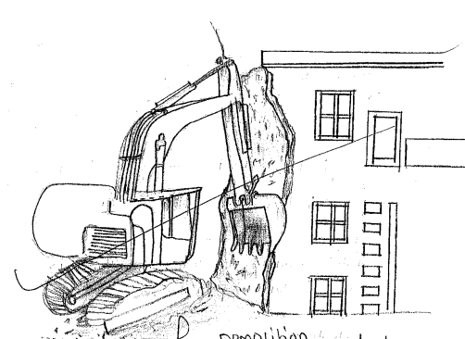

Figure 3.1: Demolition of building

3.2 SETTING OUT
In setting out for drainage, the area is levelled to determine the lowest level of area by the surveyor. The lowest area when found was marked with a peg. Using the centered peg, the width of the drainage was set out by measuring half the width of the drainage to both sides of the centered peg, and two pegs were fixed at the two measured points which were 1000mm each from the centered peg. Using a rope, the distance of the drainage was defined from the two offset pegs, with the aid of builders square. A new peg was fixed and the exert position of the rope from the peg was determined with the aid of spirit level and digger was used to transfer it to the group. The Instruments which were used are; theodolite tripod stand, pegs, builders square, rope, spirit level, and digger.
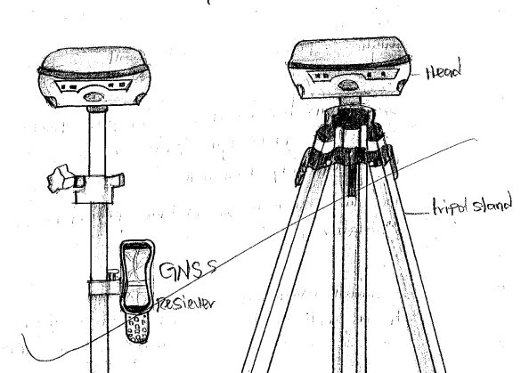
Figure 3.2: GNSS Receiver

3.3 EXCAVATION
Excavation is the loosing and removal of earth or rocks from its original position, and transporting it to spoiled bank. It was done immediately after setting out. The excavation was done by an excavator and the drainage trench was dug to a depth of 1000mm and a width of 1000mm. Excavation can be done using two methods mechanical and manual. In small construction we normally use manual method while in large construction we use mechanical e.g. like road construction.
Excavation work were carried out manually where unskilled labourer where involved with digger, shovels, head pan and wheel barrow. The following factors must be considered when carrying out any excavation work.
- Nature of the soil
- The width and depth of foundation
- Climatic condition at the time of excavation
- The water table of the soil
- The period excavation work is expected to be left open.
- The effect of excavation on existing adjacent structure.
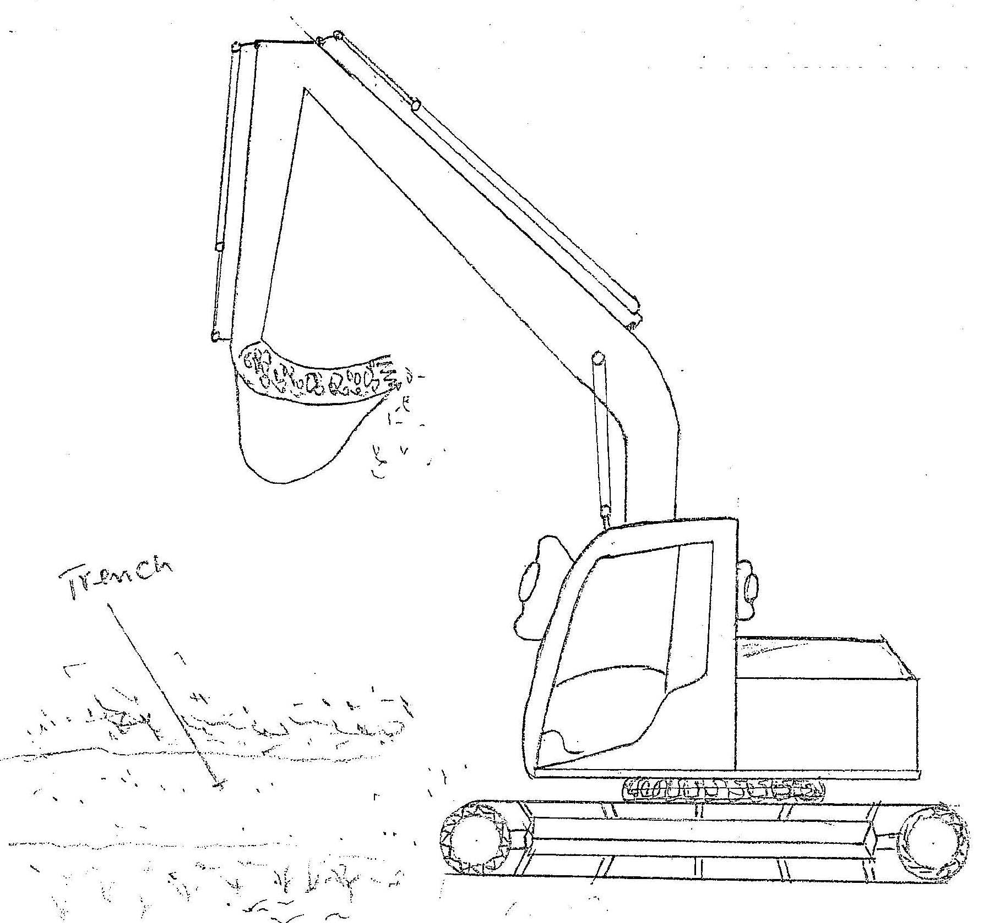
Figure 3.3: Excavator

3.4 LEVELLING
Levelling is a process of measuring the in length between two different points on the earth surface. It was done to level the difference in height between joints on the earth surface of the excavated trenches. The instruments used in levelling are as follows. Theodolite, Pegs, Tripod Stand, Suitable Graduated Staff.

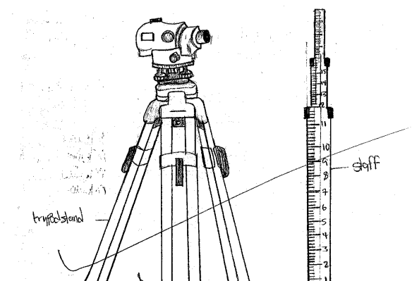

Figure 3.4: Theodolite

3.5 CONSTRUCTION OF COLUMNS AND BEAMS
After the successful installation of the wire mesh and slab preparation, we proceeded to the construction of columns and beams, which are essential components in providing vertical and horizontal support for the structure. The process began with the setting out and positioning of column reinforcements, which had already been placed at designated points during the foundation stage. We ensured that each column’s vertical bars were properly aligned and extended to the required height as specified in the structural drawings. Stirrups (ring reinforcements) were then tied around the vertical bars at specific intervals to provide lateral support and prevent buckling under load.
Next, formwork (shuttering) was erected around the column reinforcement using strong plywood and timber, firmly braced to prevent any displacement during concrete casting. Once the formwork was checked for alignment and stability, the concrete mix was poured carefully into the column molds, ensuring it filled all spaces without air gaps. We used vibrators to compact the concrete and eliminate any trapped air, which could weaken the structure.
After allowing the columns to cure for the recommended period, we moved on to the beam construction. Just like the columns, the beam reinforcements were carefully laid out, tying the top and bottom bars along with stirrups as per the structural specifications. The beams were then joined to the columns to form a continuous framework, providing support for the upper floor slab. We built strong and stable formwork for the beams, ensuring that their depth and width matched the required dimensions. Concrete was poured into the beam molds and vibrated thoroughly for compaction and to enhance strength.
Throughout the process, the site engineer supervised and inspected the work to ensure strict compliance with structural standards and safety measures. Being part of this phase allowed me to gain a deeper understanding of load distribution in buildings and the role of columns and beams in ensuring structural integrity. The successful construction of the columns and beams marked a major milestone in the building process, preparing the structure for the upper floor or roof slab construction.

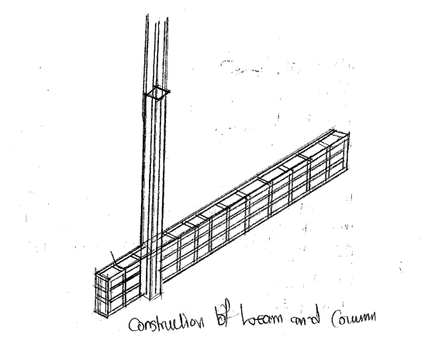
Figure 3.5: Construction of beams and column

3.6 MIXING RATIO
During my internship, I gained practical knowledge and experience in preparing concrete using the appropriate mix ratio, which is a critical factor in achieving the desired strength, durability, and workability of concrete.
The mix ratio refers to the proportion of cement, sand, and aggregates (granite or gravel) used in concrete or mortar production. The ratio we used on site depended on the structural requirement of the element being constructed—whether it was for blinding, columns, beams, slabs, or plastering.
For example:
- For blinding concrete, we commonly used a 1:4:6 ratio (1 part cement, 4 parts sand, 6 parts gravel).
- For reinforced concrete works like columns, beams, and slabs, a stronger 1:2:4 ratio was adopted.
- For plastering works, a 1:3 mix ratio (cement to sand) was used to give a fine and smooth finish.
The mixing was done both manually and mechanically using a concrete mixer depending on the volume of work. Dry materials (cement, sand, and aggregate) were first thoroughly mixed until a uniform color was achieved. Water was then added gradually to reach the desired consistency, ensuring the mix was neither too dry nor too watery.
To maintain accuracy, standard containers like head pans or wheelbarrows were used for measuring the materials. The water-cement ratio was carefully controlled, especially for structural elements, to avoid weakening the concrete and to prevent segregation and bleeding.
Proper mix ratio helped in:
- Achieving the designed compressive strength of the concrete.
- Ensuring durability and long service life of the structure.
- Enhancing workability during placement and finishing.
- Preventing structural issues such as cracking or early deterioration.
Being involved in this process gave me a deeper appreciation for the importance of correct proportioning in construction and how it contributes to the overall stability and safety of a building.
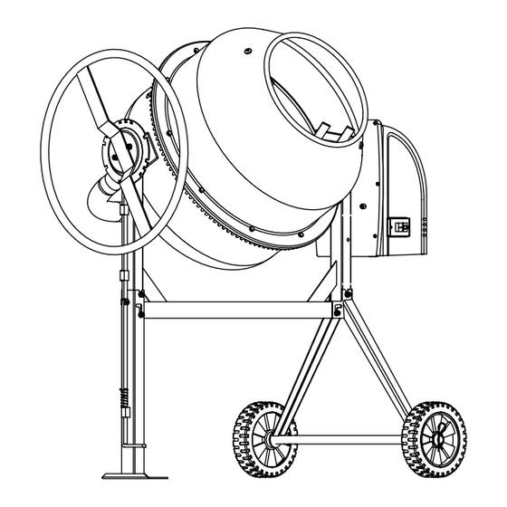
Figure 3.6: Concrete Mixer

CHAPTER FOUR

4.0 SUMMARY, RECOMMENDATION AND CONCLUTION

4.1 PROBLEMS OBSERVED DURING MY PROGRAM
- The time frame set for the program is too short as some of the aspects of the program where not completed.
- Lack of Financial support from the company to aid transportation to and from training.
- Attentions are not given to the IT students by the workers it is learn if you want to learn or ask if you want to know.

4.2 SUMMARY
One would state that the discipline is the training of the mind and body towards effective performance. The Students Industrial Work Experience Scheme (SIWES) is more or less achieving this fit. As it further builds on the theoretical classrooms leaving a practical approach of the industry and commerce to supply of finished goods and services. This program has enabled the participating students to be practically involved in the day-by-day activities of the industries and commerce.
Emphasis in the observation of industrial safety rules and regulations, time critical operation and proper man-hand management, quality cortices, etc. are daily activity objective. All those aimed at the production of marketable goods and services in the world of work.
However, to consolidate on the gains of this Industrial Training Fund (ITF) higher institution coordinator on SIWES program should be allowed making some suggestion and recommendation.

4.3 CONCLUSION
SIWES programme is very vital student especially undergraduates, because I come to see the SIWES programme provide an application of the theoretical knowledge learned by student in school to practical or real work situation. Also, it is a medium where student from different higher institutions and department come together sharing idea there, by promoting an avenue for learning and them work.

4.4 RECOMMENDATIONS
Having being exposed to a bit of what entail working in an individual related to my course of study under SIWES programme I wish to make this recommendation
- Higher instruction of learning especially either institution and universities should establish link with comprise and establishment so as to provide space for student on industrial attachment, with the option of gaining employment in future, by doing so, it will go a long way in alleviating suffering and difficulties encountered by student in securing place for individual attachment.
- Student should put money as the primary aim of going SIWES programme, there is more to learn than Bain allowance.

REFERENCES
Chudley, R. (2005). Construction technology volume 2. Pearson Prentice Hall, New York.
Edward, B. (2003). The Effect of SIWES on a student, Federal Ministry of Works, Lagos. Nigeria.
Francis, K. (2012). Building Construction Illustration. (Fourth Edition). Wiley Publisher. ISBN-10: ‎ 9788126535637.

